Hancock County High School Volleyball Pink Out Night
Monday, September 30th
All order forms and money must be turned into your school’s office by Friday, September 6th
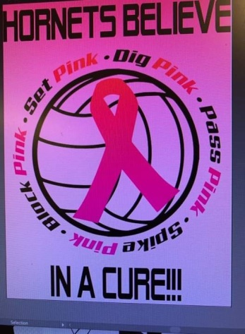
 | Youth S | Youth M | Youth L | Youth XL | Adult S | Adult M | Adult L | Adult Xl | Adult 2XL  (+$2) | Adult 3XL  (+$2)
Short Sleeve $10
Long Sleeve
$15

** Shirts are light pink with black and darker pink print.
** Please make checks payable to HCHS Volleyball Boosters.
**All profits will be donated to a local community member battling breast cancer.

Name: _________________________________ Phone ___________________

Total shirts ordered _____________ Total amount paid ___________

Shirts delivered to: HCHS ______ HCMS ______ NHES ______ SHES ______

